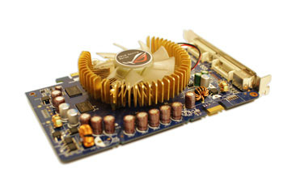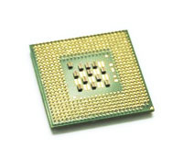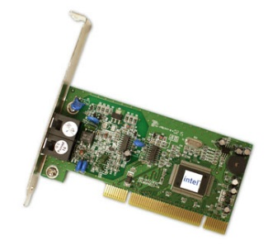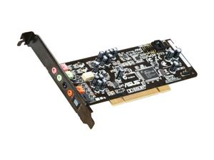C**omputing History: Level 0**

Motherboard

CPU/processor

Network Card

Sound Card

Video Card

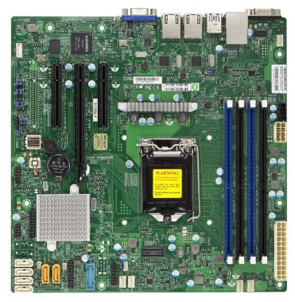

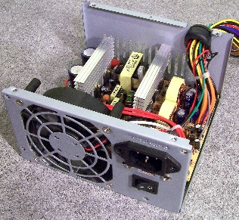

Power Supply Unit

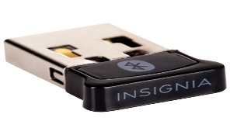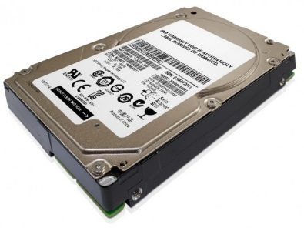

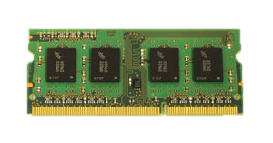

Random Access Memory

Bluetooth Card or Adapter

Hard Drive

**Level 1:**

1. **A.** The Z1 was made bv German Konrad Zuse in the vicinity of 1936 and 1938. It was worked to be the first main electro-mechanical parallel programmable PC. Additionally, the ENIAC was developed by J. Presper Eckert and John Mauchly at the college of Pennsylvania. The ENIAC was composed and used to figure mounted guns shooting rables for the US armed force.

**B and C**. IBM built up its first centralized computer PC, known as the Programmed Grouping Controlled Adding machine (ASCC), in 1944. It tackled expansion and increase issues in under six seconds. The ASCC was worked by an arrangement of thousands of vacuum tubes.

**2) a. Supercomputers were presented in the 1960s, and for quite a few years the speediest were made by Seymour Cray at Control Information Enterprise (CDC), Cray Exploration and resulting organizations bearing his name or monogram.**

**b. Dark Blue was a chess playing PC created by IBM. It is known for being the principal PC chess-playing framework to win both a chess amusement and a chess coordinate against a prevailing title holder under customary time controls.**

**c.** Quantum computing is the area of study focused on developing computer technology based on the principles of quantum theory, which explains the nature and behavior of energy and matter on the quantum (atomic and subatomic) level. Quantum computers use the power of atoms to perform memory

**3) a.** The IBM Personal Computer, commonly known as the IBM PC. It is IBM model number 5150, and was introduced on August 12, 1981. The features it includes are: [Floppy disk](https://en.wikipedia.org/wiki/Floppy_disk) or [cassette](https://en.wikipedia.org/wiki/Compact_Cassette) system and one or two internal floppy drives were optional.

**b.** The first personal computers, introduced in 1975, came as kits: The MITS Altair 8800, followed by the IMSAI 8080.

**c.** Apple Computer 1, also known later as the Apple I, or Apple-1, is a desktop computer released by the Apple Computer Company (now [Apple Inc.](https://en.wikipedia.org/wiki/Apple_Inc.)) in 1976.

**d.** The 1st generation of computers was from 1940 to 1955. Computers were powered by vacuum tubes and used magnetic drums to store data and memory. Then in 1956, the second generation of computers hit. The vacuum tubes were no longer the best thing for running a computer, the latest component to replace the vacuum tubes is a transistor. The period of transistors was not long because in 1964, integrated circuits came in. The 4th generation is still the present generation of computers. When microprocessors where invented in 1971, the era of mass usage of computers began. Before the 1st computer was invented, ‘computer’ was a job description for people who performed calculations by hand and paper, and now those job descriptions have changed to SEO (search engine optimization). Now, there are many different parts of a pc like motherboard, graphic card, the fan and etc.

**Level 2: History of Computer Components**

**1) a.** The Intel 4004 is a 4-bit central processing unit (CPU) released by Intel Corporation in 1971. It was the first commercially available microprocessor by Intel. The chip design started in April 1970, when Federico Faggin joined Intel, and it was completed under his leadership in January 1971.

**b.** An electronic circuit formed on a small piece of semiconducting material, performing the same function as a larger circuit made from discrete components.

**c.** The first modern CPU chip was built under a name that everyone today recognizes - Intel . In 1978 Intel released the Intel 8086. It was released under some pressure, as competitors were already pushing out 16-bit design and some 32-bit designs. At the time Intel had no 16-bit processor. The 1990s were largely a period where competition consisted of increasing clock speeds and larger cache sizes.

**2) a.** Ram memory is a form of Computer Data Storage which stores frequently used program instructions to increase the general speed of a system and Core memory was a common form of random access memory (RAM) from the mid-1950s to the mid-'70s, and It was developed at MIT in 1951.

**b**. Moore's law refers to an observation made by Intel co-founder Gordon Moore in 1965. He noticed that the number of transistors per square inch on integrated circuits had doubled every year since their invention.

**c.** Ram has evolved by replacing older vacuum tubes and magnetic cores to enable motherboard development and eventually allowing computers as we know them today to develop.

**d.** Computers have two kinds of storage- temporary and permanent. A computer’s **memory** is used for **temporary** storage, while a computer’s **hard drive** is used for **permanent** storage.

**3) a.** VGA  is the display hardware first introduced with the IBM PS/2 line of computers in 1987. Through widespread adoption, the term has also come to mean either an analog computer display standard, the 15-pin D-subminiature VGA connector, or the 640×480 resolution characteristic of the VGA hardware.\

b. 9 pin D-Subminiature

c. They were first introduced in 1995. The first one was known as [GeForce 256](https://en.wikipedia.org/wiki/GeForce_256). It was presented as a single-chip processor with integrated [transform, lighting, triangle setup/clipping](https://en.wikipedia.org/wiki/Transform,_clipping,_and_lighting), and rendering engines".

d. Graphics cards have come a long way, and are now able to rapidly solve complex physics calculations, process large amounts of polygons, and render high-resolution textures. The industry has been dominated by two GPU manufacturers, Nvidia and AMD. The companies are competing at the cutting-edge of graphics technology and are constantly refining and improving their products.

**Level 3**

1. The software that supports a computer's basic functions, like ending tasks.
2. computer software is all information processed by computer systems, programs and data. So, basically it processes information.
3. A driver is a software component that lets the operating system and a device communicate with each other
4. perform routine maintenance or repair work on a computer.
5. A. The term DOS can refer to any operating system, but it is most often used as a shorthand for MS-DOS (Microsoft disk operating system). Originally developed by Microsoft for IBM, MS-DOS was the standard operating system for IBM-compatible personal computers.

B) Windows 1.x. The first independent version of Microsoft Windows, version 1.0, released on November 20, 1985. It contained a graphical, 16-bit multi-tasking shell on top of an existing MS-DOS installation.

3.

A) UNIX is a widely used multiuser operating system. Unix is a family of multitasking, multiuser computer operating systems that derive from the original AT&T. Unix developed starting in the 1970s at the Bell Labs research center by Ken Thompson, Dennis Ritchie, and others.

B)Linux is an operating system modelled on UNIX. So, basically LINUX is a Unix-like computer operating system assembled under the model of software

development and distribution.

C) Both Mac OS X, the operating system used on Apple's desktop and notebook computers, and Linux are based on the Unix operating system, which was developed at Bell Labs in 1969 by Dennis Ritchie and Ken Thompson